**BIOGRAPHY**

***U N I T E D S T A T E S A I R F O R C E***

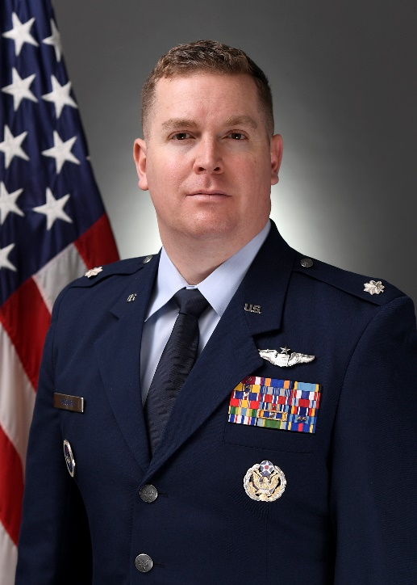**LIEUTENANT COLONEL RYAN M. McGUIRE**

Lieutenant Colonel Ryan M. McGuire is the Commander, 33rd Student Squadron, Squadron Officer School, Maxwell Air Force Base, Alabama. He commands a

selectively manned squadron of instructors and students as part of

Squadron Officer School. The 33d Student Squadron “Tigers” provide

Professional Military Education, developing over 650 mission-ready, joint-minded company grade officers, international officers and Department of Defense civilians annually.

Lieutenant Colonel McGuire graduated from the University of Colorado in 2009 with a Bachelor of Science in Finance and Human Resource Management. He commissioned through the Reserve Officer Training Corps, Detachment 105 as a distinguished graduate. Lieutenant Colonel McGuire attended Specialized Undergraduate Pilot Training at Laughlin AFB, Texas. After graduation he was selected as a First Assignment Instructor Pilot in the T-1A Jayhawk. While assigned as a KC-10A Evaluator Pilot, Lieutenant Colonel McGuire built the first-ever Airmen driven innovation program called Phoenix Spark. He later served as an Executive Officer to the Commander, Air Force Operations Group, and as a Legislative Fellow in the office of Representative Ann Kirkpatrick and as a Congressional Budget and Appropriations Liaison. In this role, he interfaced directly with Members of Congress, their staffs, and Defense Appropriations Committee Professional Staff Members to defend a portfolio consisting of aircraft procurement, research, development, test and evaluation appropriations for all mobility, training, special operations, and helicopter platforms in the Air Force. Prior to this assignment, he served as the Director of Operations for the 33rd Student Squadron ensuring standardized curriculum execution for the department’s $24-million resident professional development education leadership course

Lieutenant Colonel McGuire has deployed three times in-support of OPERATIONS INHERENT RESOLVE and FREEDOM'S SENTINEL.

# EDUCATION

2009 Bachelor of Science, Finance and Human Resource Management, University of Colorado, CO

2010 Air and Space Basic Course, Maxwell AFB, AL

2013 Squadron Office School, (by correspondence) Maxwell AFB, AL

2014 Master of Science, Leadership, Strategic Innovation & Change Management, Colorado State University, CO

2014 Squadron Officer School, Maxwell AFB, AL

2017 KC-10A Instructor Pilot Upgrade, Travis AFB, CA, distinguished graduate

2020 Air Command and Staff College, (by correspondence), Maxwell AFB, AL

2021 Air Force Legislative Fellowship, Washington, DC

2021 Certificate in Legislative Studies, Georgetown University, Washington DC

# ASSIGNMENTS

1. November 2009-May 2011, student, specialized undergraduate pilot training, Laughlin Air Force Base, TX

2. August 2011-December 2011, student, Pilot Instructor Training, Randolph Air Force Base, TX

3. January 2012 - April 2015, Flight Scheduler, Squadron Executive Officer, Deputy Squadron Training, Operations Group Executive Officer and T-1A Instructor Pilot, Laughlin AFB, TX

3. April 2015-February 2019, Chief of Mission Generation, Flight Commander, Chief Wing PHOENIX SPARK Program, and KC-10A Evaluator Aircraft Commander, Travis AFB, CA

4. February 2019 – June 2020, Executive Officer, Air Force Operations Group, Pentagon, VA

5. July 2020 – December 2021, Air Force Legislative Fellow, State Department and U.S. House of Representatives, Washington, DC

6. January 2022 – June 2024, Congressional Budget and Appropriations Liaison, Deputy Assistant Secretary for Congressional Budget and Appropriations (SAF/FML), Pentagon, VA

7. June 2024 – June 2025, Director of Operations, 33rd Student Squadron, Maxwell AFB, AL

8. June 2025 – Present, Commander, 33rd Student Squadron, Maxwell AFB, AL

# FLIGHT INFORMATION

Rating: Senior Pilot

Flight Hours: More than 2,400

Aircraft Flown: T-6, T-1, KC-10A

# MAJOR AWARDS AND DECORATIONS

Meritorious Service Medal w/two oak leaf clusters

Air Medal

Aerial Achievement Medal

Air Force Commendation Medal w/one oak leaf cluster

Air Force Expeditionary Service Ribbon with Gold Border and one oak leaf cluster

Air Force Special Duty Ribbon

# EFFECTIVE DATES OF PROMOTION

Second Lieutenant May 8**,** 2009

First Lieutenant August 6, 2011

Captain August 6, 2013

Major June 1, 2019

Lieutenant Colonel October 1, 2023

# (Current as of July 2025)