|  |  |  |  |
| --- | --- | --- | --- |
| |  |  |  | | --- | --- | --- | | Seal | Biography | Flag | |
| ***U N I T E D   S T A T E S   S P A C E   F O R C E*** |

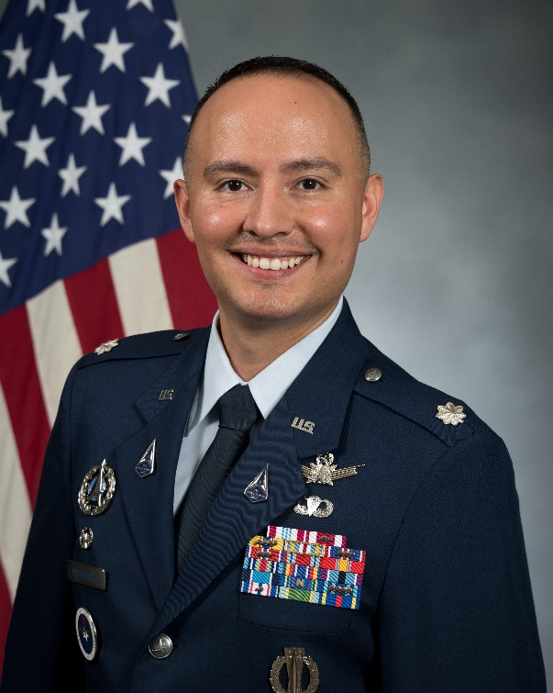**LT COL JOHANN A. PAMBIANCHI**

Lt Col Johann A. Pambianchi is the Commander, 30th Student Squadron, Maxwell Air Force Base, Alabama. He commands a selectively manned squadron of instructors and students as part of Squadron Officer School. The 30th Student Squadron “Knights” provide Professional Military Education to more than 600 Air and Space Force Captains, International Officers, and Department of the Air Force Civilians annually. His squadron also executes the Spacepower Education and Advanced Readiness track to meet developmental requirements of space professionals.

Lt Col Pambianchi earned his commission in 2007 through the US Air Force Academy with a Bachelor of Science in Space Operations. In 2012, he graduated from Embry-Riddle Aeronautical University with a Master of Aeronautical Science with a focus in Space Studies. In 2021, he graduated from the Schriever Space Scholars Program, the nation's first year-long space-centric Intermediate Development Education (IDE) program dedicated to developing space strategists.

Prior to his current position, Lt Col Pambianchi served as the Chief, Space Strategy Division at Headquarters United States Space Force, the Pentagon, Washington D.C. Lt Col Pambianchi has operational experience in Intercontinental Ballistic Missiles, space lift, satellite command and control, and joint/interagency space defense. He served as the first training branch chief for the newly established National Space Defense Center (NSDC), Schriever AFB, CO.

**EDUCATION**

2007 Bachelor of Science, Space Operations, United States Air Force Academy, CO.

2007 Air and Space Basic Course, Maxwell AFB, AL.

2012 Master of Aeronautical Science, Embry-Riddle Aeronautical University, FL (World-wide).

2014 Squadron Officer School, Maxwell AFB, AL.

2021 Master of Military Operational Art and Science, Air Command and Staff College, Maxwell AFB, AL.

2024 Air War College, Maxwell AFB, AL (by correspondence)

**ASSIGNMENTS**

1. May 2007 – Oct 2007, Student, Air and Space Basic Course, Maxwell AFB, AL

2. Oct 2007 – Mar 2008, Student, Specialized Undergraduate Pilot Training, 84 FTS, Laughlin AFB, TX

3. Mar 2008 – Oct 2008, Student, Undergraduate Missile Training, 392 TRS, Vandenberg AFB, CA

4. Oct 2008 – Jun 2011, Deputy Missile Combat Crew Commander; Missile Combat Crew Commander, 12 MS, Malmstrom AFB, MT

5. Jun 2011 – Oct 2012, Instructor; Chief of Requirements; Chief of Current Operations, 341 OSS, Malmstrom AFB, MT

6. Oct 2012 – Aug 2013, Range Operations Commander, 1 ROPS, Cape Canaveral AFS, FL

7. Aug 2013 – Feb 2014, Instructor; Chief of Training; Flight Commander, Weapons and Tactics, 45 OSS, Cape Canaveral AFS, FL

8. Feb 2014 – May 2014, Executive Officer to Operations Group Commander, 45 OG, Patrick AFB, FL

9. May 2014 – Oct 2015, Deputy Director of Staff, 45 SW, Patrick AFB, FL

10. Oct 2015 – Jan 2017, Training Flight Commander; Assistant Director of Operations, 3 SOPS, Schriever AFB, CO

11. Feb 2017 – May 2018, Chief, Training Branch, TR-EX Division, National Space Defense Center, Schriever AFB, CO

12. Jun 2018 – Mar 2019, Operations Officer, 30 OSS, Vandenberg AFB, CA

13. Apr 2019 – May 2020, Air University Fellow/Flight Commander, 31 STUS, Maxwell AFB, AL

14. Jun 2020 – June 2021, IDE Student, Air Command and Staff College, 21 STUS, Maxwell AFB, AL

15. June 2021 – June 2022, Deputy Department Chair, Spacepower, ACSC, Maxwell AFB, AL

16. July 2022 – June 2024, Chief, Space Strategy Division, HQSF S5/8, the Pentagon, Washington DC

17. June 2024 – Present, Commander, 30th Student Squadron, Maxwell AFB, AL

**MAJOR AWARDS AND DECORATIONS**

Defense Meritorious Service Medal

Meritorious Service Medal with Two Oakleaf Clusters

Air Force Commendation Medal with Four Oakleaf Clusters

**PUBLICATION**

“Advancing America’s Space Characterization Ecosystem: An Organizational, Technological, and Data-Driven Approach to Addressing Tomorrow’s Space Conflicts” with Lt Col Jason Holt and Lt Cdr Barrett Sleeper, Fairchild Papers (Maxwell AFB, Ala.: Air University Press, May 2022).

**OTHER ACHIEVEMENTS**

Academic Achievement, Space 100

Distinction, Embry-Riddle Aeronautical University (world-wide)

Top Third Flight, Squadron Officer School

Distinguished Graduate, Schriever Space Scholars, Air Command and Staff College (ACSC)

Air Force Association’s General Carl A. Spaatz Award for research excellence, ACSC

Master Instructor, Air Education and Training Command (AETC)

**EFFECTIVE DATES OF PROMOTION**

Second Lieutenant May 30, 2007

First Lieutenant May 30, 2009

Captain May 30, 2011

Major March 1, 2017

Lt Col March 30, 2022

(*Current as of July 2024*)