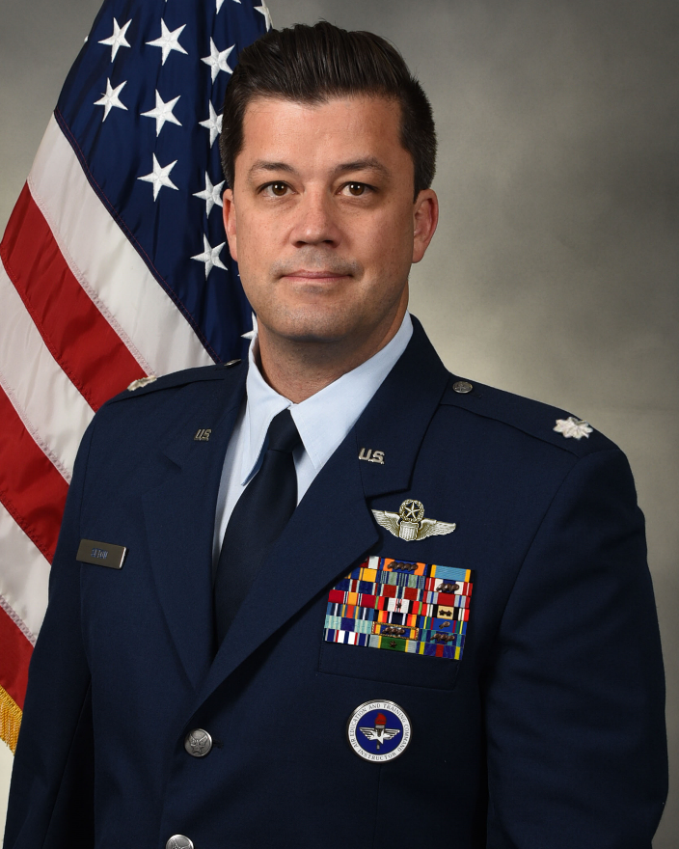
LIEUTENANT COLONEL BRENT E. SETON
Insert Official Photograph Here. Click inside the gray box, then use “Insert Picture” or Copy+Paste a picture.
Photograph should be resized to 3.2” wide by 4” high with a locked aspect ratio. Use cropping as required.
Photography should be taken in full service dress IAW AFI 36-2903. Consult your local public affairs office for guidance in taking an official photograph.

Lt Col Brent Seton is the Director of Operations and Logistics for Squadron Officer School, Maxwell Air Force Base, Alabama. Lt Col Seton leads a 17-member faculty of military and civilian personnel and directs operations and logistics for Professional Military Education for over 3500 captains every year.

Lt Col Seton is a 2002 graduate of Walla Walla University with a degree in Aviation. In 2007 Lt Col Seton was commissioned through Officer Training School and then moved to Laughlin AFB, TX for Undergraduate Pilot Training (UPT). He completed UPT at Ft. Rucker, AL with helicopter training. As an HH-60 pilot, Lt Col Seton has completed four deployments in support of Operations IRAQI FREEDOM, NEW DAWN, and ENDURING FREEDOM and is credited with over 60 combat saves. Prior to his current position, Lt Col Seton was the Director of Operations for the 32nd Student Squadron at Squadron Officer School.

EDUCATION
2006 Bachelor of Science in Aviation, Walla Walla University, College Place, WA
2007 Officer Training School, Maxwell AFB, AL
2007 Air and Space Basic Course, Maxwell AFB, AL
2013 Squadron Officer School, Maxwell AFB, AL
2019 Leadership Development Course, Maxwell AFB, AL
2020 Air Command and Staff College, Maxwell AFB, AL
2025 Air War College, Maxwell AFB, AL

ASSIGNMENTS
- May 2007 – September 2008, student pilot, UPT, 47th Operations Support Squadron, Laughlin AFB, TX
- September 2008 – May 2009, student pilot, SUPT, 23d Flying Training Squadron, Ft. Rucker, AL
- May 2009 – April 2014, HH-60G pilot, 66th Rescue Squadron, Nellis AFB, NV
- April 2014 – July 2017, TH-1 Instructor Pilot, 23d Flying Training Squadron, Ft. Rucker, AL
- July 2017 – January 2019, HH-60G Instructor Pilot, 56th Rescue Squadron, Aviano AB, Italy
- January 2019 – January 2021, HH-60G Instructor Pilot, Chief, Nuclear Plans & Programs, 31st Fighter Wing, Aviano AB, Italy
- January 2021 – March 2022, Flight Commander, 217th Training Squadron, Officer Training School, Maxwell AFB, AL
- March 2022 – April 2023, Assistant Director of Operations, 217th Training Squadron, Officer Training School, Maxwell AFB, AL
- April 2023 – March 2024, Deputy Director, Air University Innovation Accelerator, Air University, Maxwell AFB, AL
- March 2024 – January 2025, Director of Operations, 32nd Student Squadron, Squadron Officer School, Maxwell AFB, AL
- January 2025 – Present, Deputy Director of Operations and Logistics, Squadron Officer School, Maxwell AFB, AL

FLIGHT INFORMATION
Rating: Command Pilot
Flight hours: 1950 hours
Aircraft flown: T-6, UH-1, TH-1, and HH-60G

MAJOR AWARDS AND DECORATIONS
Meritorious Service Medal with two oak leaf clusters
Air Medal with four oak leaf clusters
Aerial Achievement Medal

EFFECTIVE DATES OF PROMOTION
Second Lieutenant April 27, 2007
First Lieutenant April 27, 2009
Captain April 27, 2011
Major January 1, 2017
Lieutenant Colonel September 1, 2022

(Current as of Jan 2026)

