Exception to Policy (ETP) Checklist
ETPs are required for the following:
  - Student’s current PFA has component exemptions
  - Student’s PFA is non-current/exempt due to PT testing pause, deployment, and/or acclimatization
  - Student is on a medical/duty limiting profile for physical activity

- Review the ETP requirements chart to determine which documents are required for your situation.

- Send SOS Student Services an email with your completed ETP package NLT the ETP/Waiver deadline and attach the following documents:
(See Course Dates and Deadlines or Eligibility Requirements tab on SOS Website)
  - Tab 1 – Wing/CC (or equivalent) MFR
  - Tab 2 – SURF
  - Tab 3 – current myFitness Report
  - Tab 4 – DAF Form 469 (profile – if applicable)
  - Tab 5 – PCM MFR (if applicable)

- If your ETP is APPROVED, no further action required. Welcome to SOS!

- If your ETP is DENIED, work with your Unit Training Manager (UTM) to be formally removed from the class. You will receive a cancellation RIP when this action is complete. Failure to be formally removed from the class will result in a NO-SHOW.
- ALWAYS check the status of your ETP. Do NOT assume that you are cleared to proceed to SOS without confirming your ETP is approved.

- You may contact SOS Student Services directly regarding your ETP package.
SOS Student Services: DSN 493-3231, email sos.od.studentservices@us.af.mil.



Your Organizational Letterhead here

MEMORANDUM FOR SOS/CC
FROM: XYZ WG/CC
SUBJECT: Medical Profile ETP for Capt FIRST LAST

Insert a brief explanation of the reason you are requesting an exception to policy. If you are unable to attend SOS at a later date after your medical profile expires, this should be made explicitly clear and should include supporting evidence.

Example:

- Capt Doe is currently on a medical profile and due to a substantial recovery period, this is Capt Doe’s last look for SOS before becoming ineligible to attend/Capt Doe is within two years of their promotion board to Major. I request an exception to policy for Capt Doe to attend SOS Class 26X.
- Capt XXXX commissioned in XXXX, has a DOR to Captain in 20XX, and will meet the O4 promotion board in 20XX

- If there are any questions or comments please contact Lt Col Jake Doe, 82 FS/CC (must be member’s SQ/CC or equivalent), DSN: XXX-XXXX.

JOHN M. DOE, Colonel, USAF

Commander

4 Attachments:
- Capt Doe’s SURF
- Capt Doe’s myFitness Report
- Capt Doe’s DAF Form 469 (profile – if applicable)
- Capt Doe’s MFR from PCM (if applicable)

EXAMPLE - AF Fitness Assessment Management System (AFFMS/myFitness Report) Printout
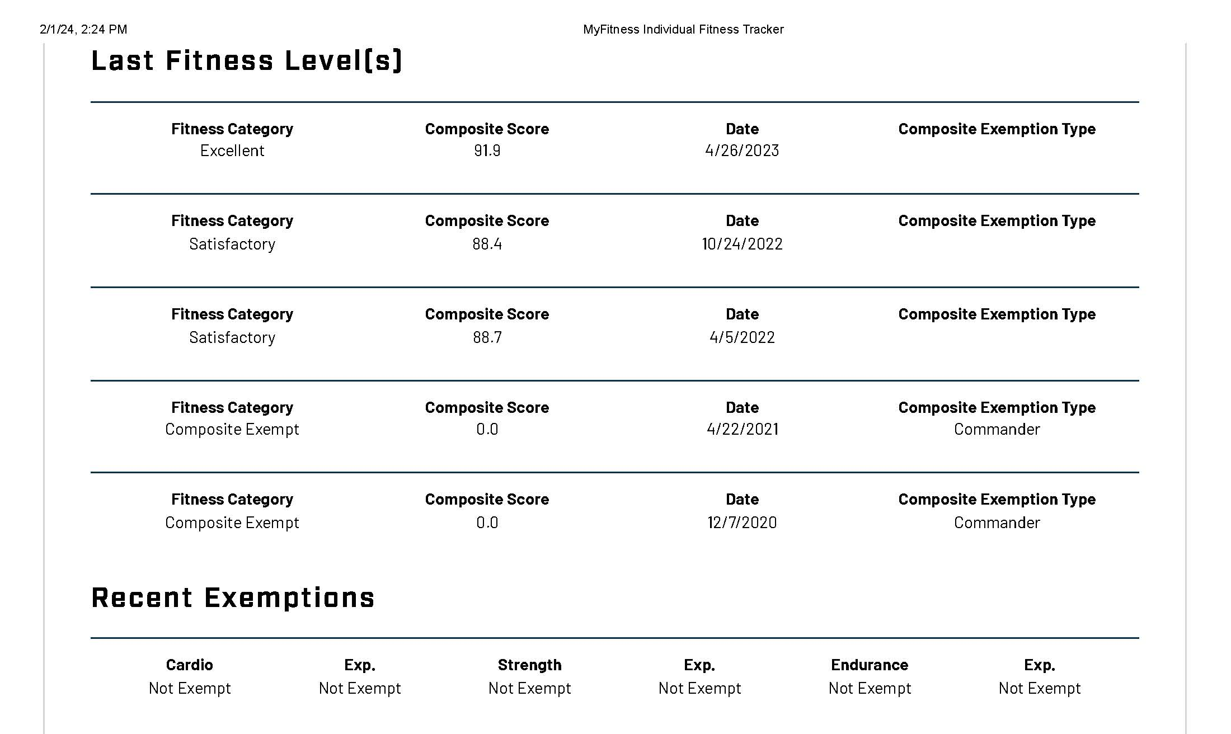
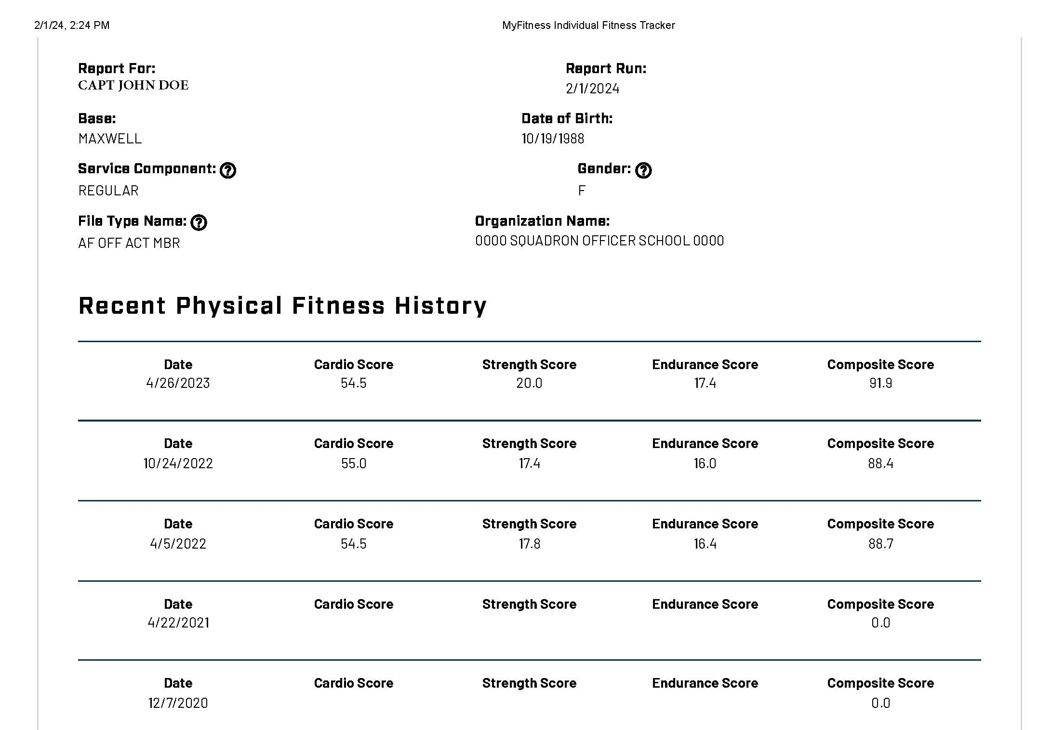
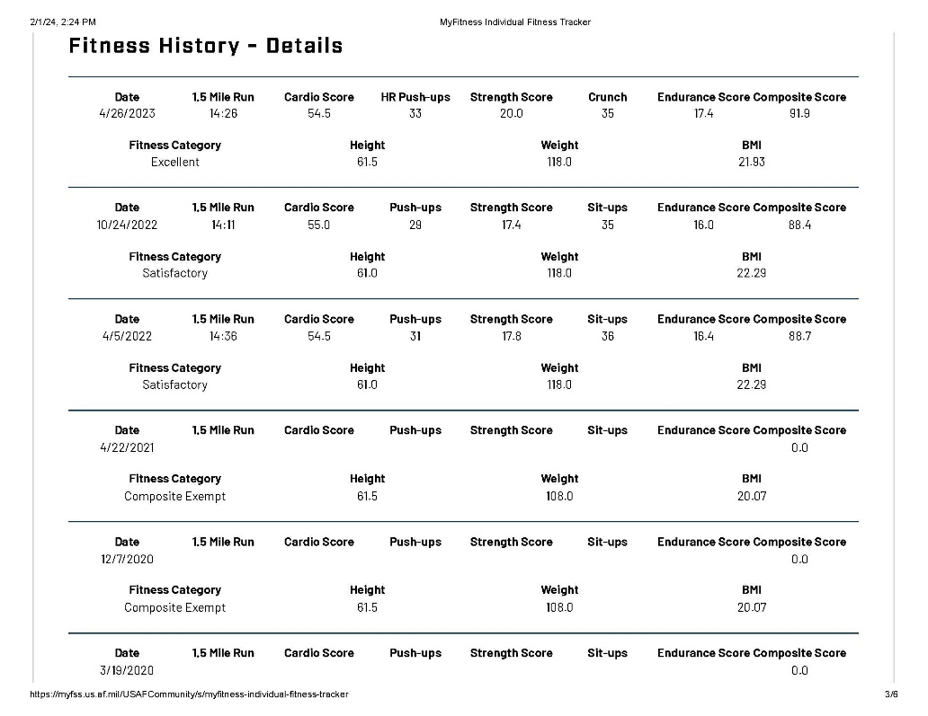
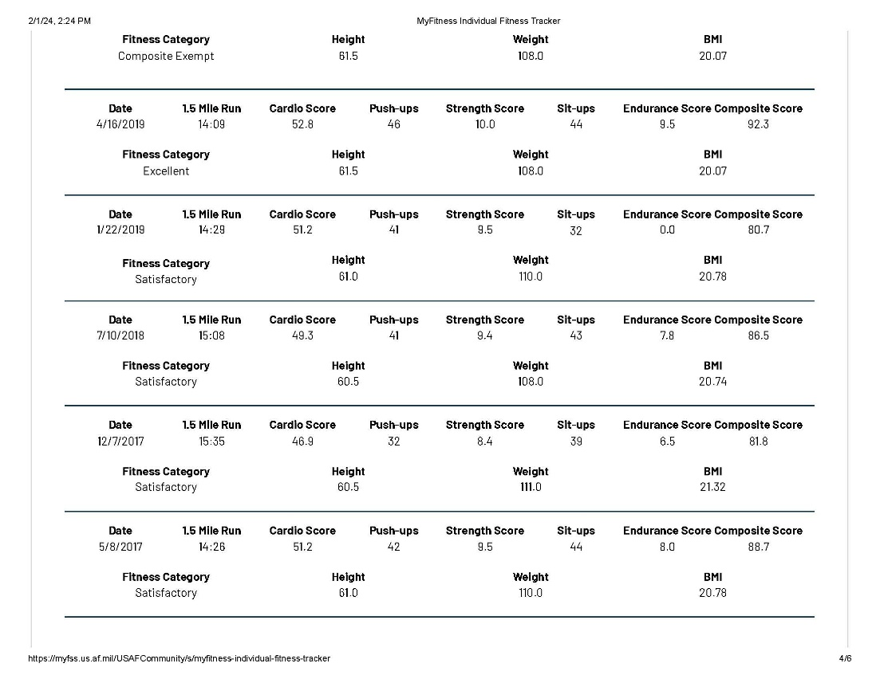
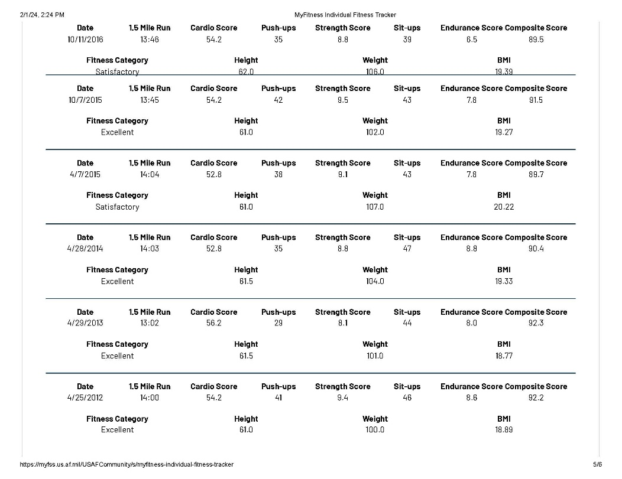

EXAMPLE - AF FORM 469
(available from Medical Provider)
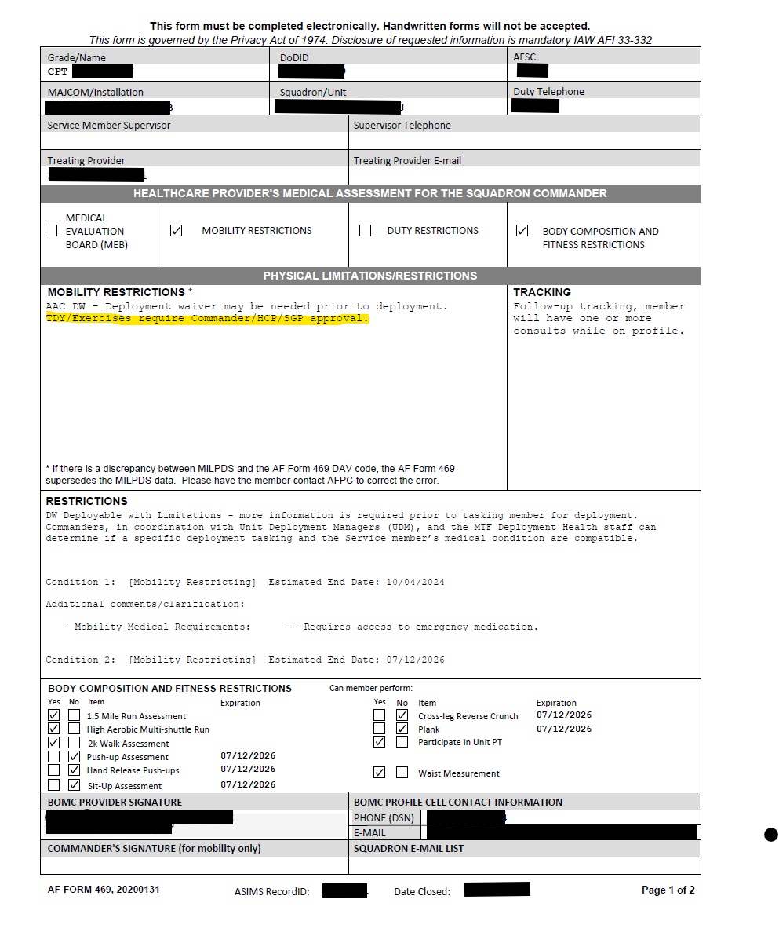
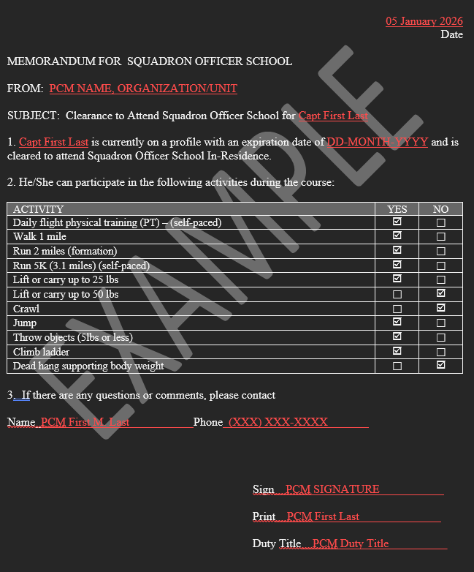
EXAMPLE - Primary Care Manager (PCM) MFR

