# PKE Certificates for MacOS

Required Downloads **(https://iase.disa.mil/pki-pke/pages/tools.aspx)**

* Using the link above, choose the "Trust Store" tab
  + Your web browser may say "This Connection is not Private". If this is the case, click "Show Details", then click "Visit this Website"
    - This is caused by the certificates not being installed on your computer
  + Download the PKI CA Certificate Bundles: PKCS#7 For DoD PKI Only

Required Devices

* MacOS Computer (Ensure it is completely updated)
* DoD Approved CAC Reader (The last page of the document at the bottom of the page lists DoD Approved CAC readers)

Guide

1. The file downloaded from the website above should be located in the downloads section of your toolbar, drag it to your desktop (Figure 1)
2. Using the search function (top right corner), search for Keychain and open the app called "Keychain Access" (Figure 2)
3. Select the keychain named "System" on the left side.
4. Open the PKCS folder
5. Double click on the first file and input your password (or use TouchID) to verify the changes to the Keystore
   1. You should see a number of certificates appear in the Keychain Access App
6. Right (or two finger) click on the certificate with a red x on the picture
   1. This should be called "DoD Root CA 2"
7. Click "Get Info" and expand the "Trust" section (Figure 3)
8. Change the "When using this certificate:" drop down from "Use System Defaults" to "Always Trust" (Figure 4)
9. Close this window and enter your password again to allow changes to the System Certificate Trust Settings
10. Repeat steps 5-9 for the next three files and update the trust settings for the "DoD Root CA 3", "DoD Root CA 4", and "DoD Root CA 5" certificates
11. The rest of the files are not needed and the entire folder can now be deleted (Figure 5)

*DoD Approved CAC Readers*

https://iasecontent.disa.mil/pki-pke/unclass-dodcac_release1-0_reader_require_v1-01.pdf

PKE Certificates for Windows

### Required Downloads (https://iase.disa.mil/pki-pke/pages/tools.aspx)

* Using the link above, choose the "Trust Store" tab
  + Your web browser may say "This Connection is not Private". If this is the case, click "Show Details", then click "Visit this Website"
  + Download and install the correct version of InstallRoot 5.2 for your environment
    - See: How do I determine my environment?

### Required Devices

* Windows 8/10 PC (Ensure it is completely updated)
* DoD Approved CAC Reader (The last page of the document at the bottom of the page lists DoD Approved CAC readers)

### Guide

1. Open InstallRoot 5.2 as an administrator
   1. To open it as an administrator, right click the shortcut to open InstallRoot, and select "Run as Administrator"
   2. If InstallRoot 5.2 prompts you to allow it to manage other certificate stores (NSS or Java), check the box for "Don't ask me about this store again" and click "Yes"
2. When InstallRoot opens, ensure that you are on the tab saying "Microsoft Local Computer"
3. Make sure "Install DoD Certificates" has a green check next to it
   1. All others should have a red x next to them
   2. If one or more of these is incorrect, click the red x or green check to change it
4. Click "Install Certificates"

*NOTE* If you plan to use Mozilla Firefox, please follow the below steps:

1. Choose the tab that says "Multi-NSS
2. Click "Install Certificates"
3. All certificates should now be installed.

*DoD Approved CAC Readers*

https://iasecontent.disa.mil/pki-pke/unclass-dodcac_release1-0_reader_require_v1-01.pdf

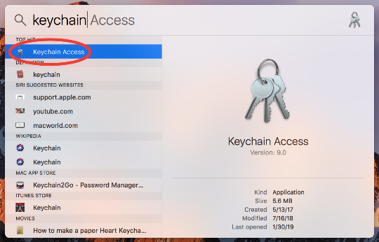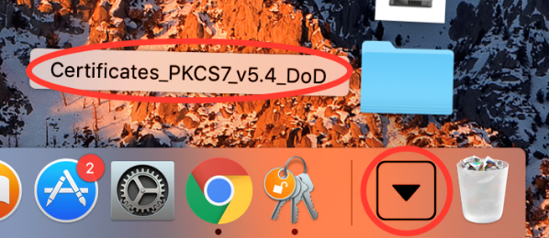

Figure 1

Figure 2

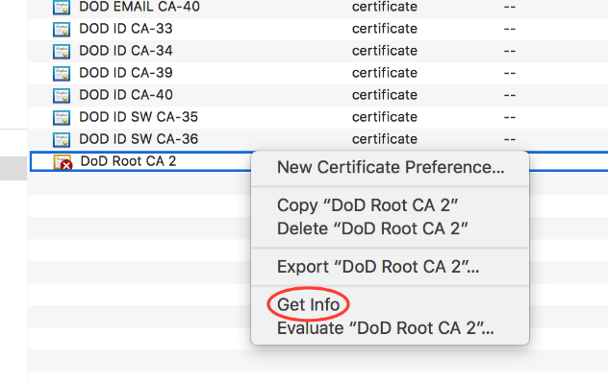

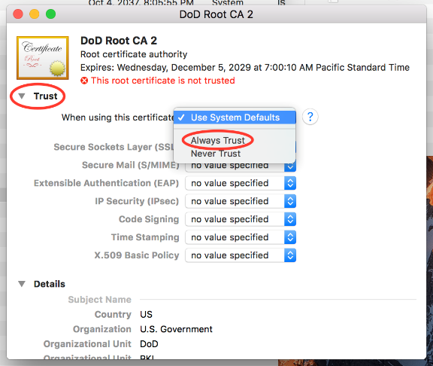

Figure 4

# D:\InstallRootRun1.PNGD:\InstallRootRun2.PNGD:\MacOSPKE5.pngHow do I Determine my Environment?

Figure 6

Figure 7

Figure 3

Figure 5

## **Am I an administrator?**

The first thing we will check is wether or not your account is an administrator account. If not, you will not be able to install the certificates or certificate management programs used in this series of guides. If your account is determined to not be an administrator, you will need the administrator accounts password, or the system administrator to perform the installations in other guides.

Windows

1. Click on the Windows Start button in the bottom left corner of the display
2. Click on the Settings tile (Figure 8)
3. Click on Accounts (Figure 9)
4. It should show the current logged in accounts name as well as whether or not it is an administrator in the indicated position. (Figure 10)

MacOS

1. Click on the apple in the top left corner
2. Click on System Preferences (Figure 11)
3. Click on Users & Groups (Figure 12)
4. Your account name will say Admin underneath it if it is an administrator (Figure 13)

## **What Environment am I on?**

This short guide will help you determine if your Windows Operating System is 32-bit or 64-bit. This guide requires no special permissions or steps.

1. Press the 'Windows' key and the 'R' key at the same time (Note: the 'Windows" key is the little flag key on the bottom left of your keyboard)
2. Type 'dxdiag' into the box that appears (Figure 14)
3. If it asks "Would you like to check for digitally signed drivers?" select 'Yes'
4. On the page that pops up and next to where it says "Operating System:" it will says your windows version and 64-bit or 32-bit (Figure 15)

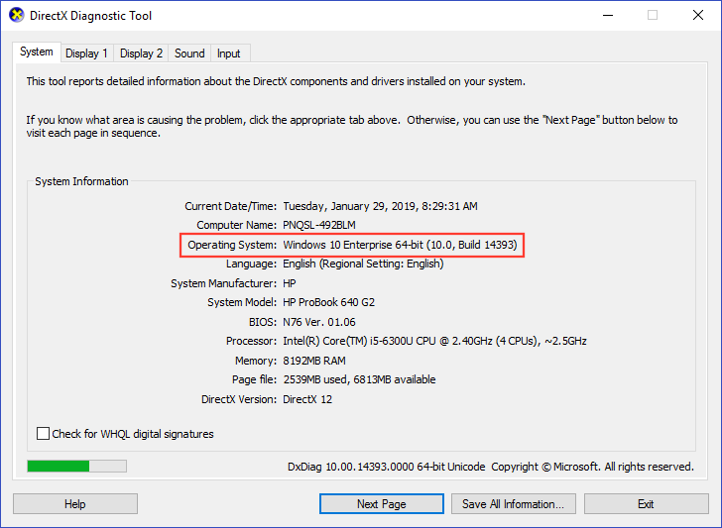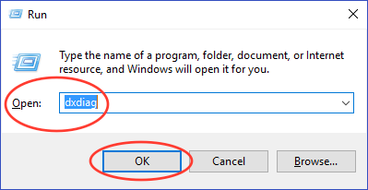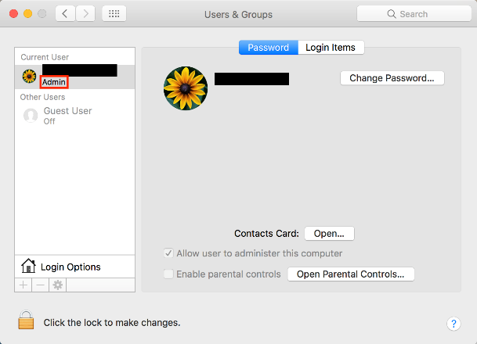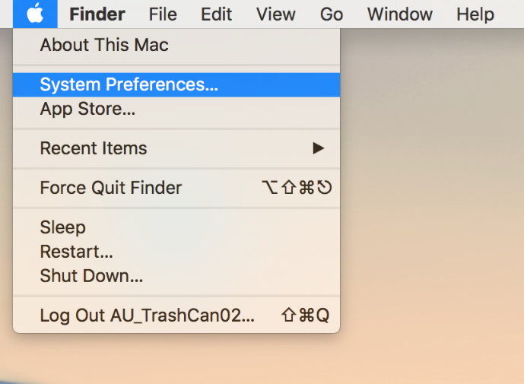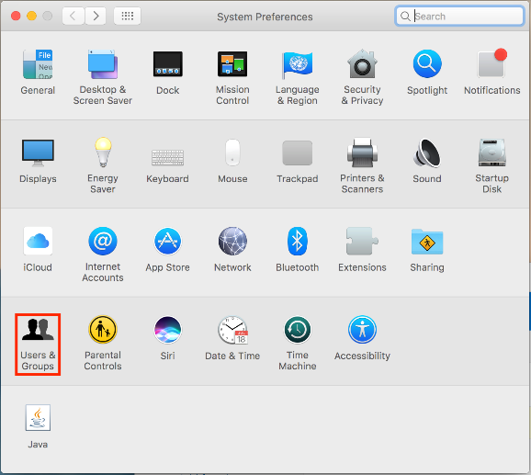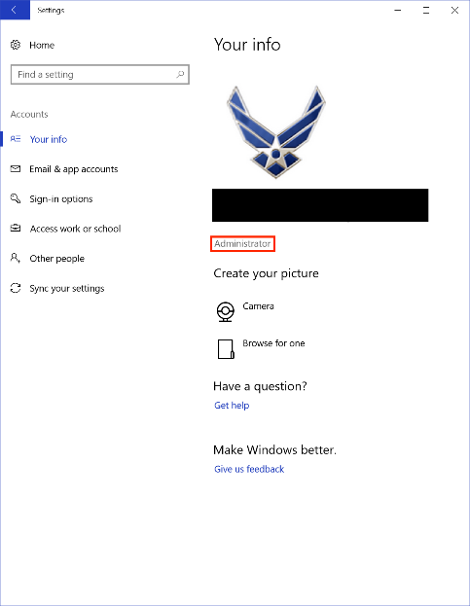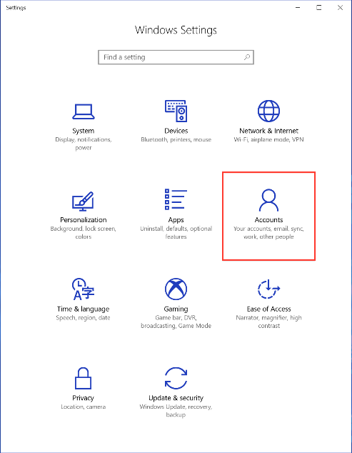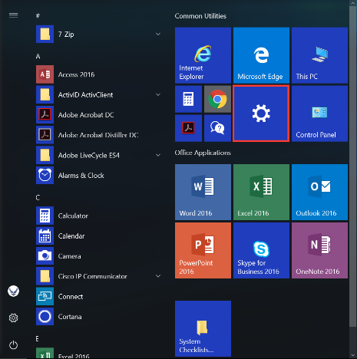

Figure 15

Figure 14

Figure 13

Figure 12

Figure 11

Figure 9

Figure 10

Figure 8